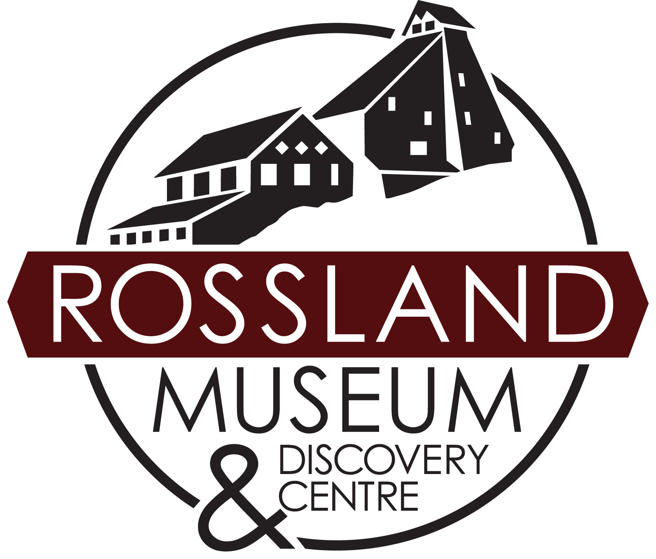
RHMAA Trustee Nomination Form
The Rossland Historical Museum & Archives Association (DBA Rossland Museum & Discovery Centre) is governed by a volunteer Board of Trustees made up of community members. The maximum number of Trustees per year is eleven. Trustee terms are for two years.

Name: _____________________________________ Phone: _________________________________________
Email: _____________________________________ Address: ________________________________________
_________________________________________________________________________________________________

Why are you interested in the Rossland Museum & Discovery Centre? _________________________________________
________________________________________________________________________________________________________________________________________________________________________________

Other volunteer commitments: _______________________________________________________________
________________________________________________________________________________________

Skills Matrix Information
Profession (or previous profession if retired): ____________________________________________________

Skills & Experience Assessment Scale:  1 (low)  2 (moderate)  3 (high) | Financial Management | 1 | 2 | 3
 | Human Resources | 1 | 2 | 3
 | Governance ((i.e. drafting policy, knowledge of the Societies Act, board roles & responsibilities, etc) | 1 | 2 | 3
 | Strategic Planning | 1 | 2 | 3
 | Fundraising & Revenue Development | 1 | 2 | 3
 | Advocacy & Government Relations | 1 | 2 | 3
 | Communications/Marketing Outreach | 1 | 2 | 3
 | Program Development/Project Planning | 1 | 2 | 3

Our Organization supports Justice, Equity, Diversity, and Inclusion and wishes to reflect these values in our board, volunteers, and staff. Do you identify as belonging to an equity-seeking or underrepresented population? Yes | No | Prefer not to answer

Is there something special you would bring to the Rossland Museum that wasn’t captured by the previous questions? Please share any special skills, experiences, or connections here: __________________________ ________________________________________________________________________________________
________________________________________________________________________________________

Which committee(s) would you be interested in being involved in? (circle all that apply)
Policy | Human Resources | Collections & Research | Community Engagement | Finance

Thank you for completing this application for Board of Trustee membership. Please drop it off or mail it to us in care of RHMAA Board of Trustees. Our Nominating Committee will be in touch with you.

